February 18, 2022
Associate Professor Luke Wilson
Chair, Arts and Sciences Curriculum Committee

Re: Approval of Name Change to the in-person MA in Art Education Program

Dear Luke and Members of the Arts and Sciences Curriculum Committee,
At its meeting on Thursday, January 27, 2022, the Arts and Humanities 2 Panel of the ASC Curriculum Committee unanimously approved the Department of Arts Administration, Education & Policy’s request to change the name of the in-person MA in Art Education program to show how it differs from the MA in Art Education online program. The proposed name change is MA in Art Education & Public Pedagogy.
We believe that the proposed name change better represents how the in-person MA’s curriculum allows students to engage with public-facing spaces such as schools and museums focusing on Art Education as a form of public pedagogy, something that can be more easily learned in an in-person program. While the name change does not imply and changes to the in-person curriculum, it is important to note that students pursuing the in-person degree cannot take more than three online courses.
Thus, we advance the proposed revision to the Arts and Sciences Curriculum Committee with a motion to approve.
Regards,
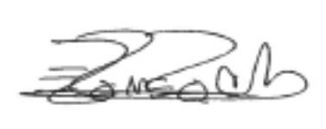
Eugenia Romero, PhD
Associate Professor of Iberian Studies
Vice-Chair and Director of Undergraduate Studies
Department of Spanish and Portuguese

